Title of the Paper

Author A¹, Author B¹∗, Author C², …, Author N^{M}
Name of Institution 1, Address
Name of Institution 2, Address
…
Name of Institution M, Address

Abstract

This document serves as a guide for writing a technical paper that will be submitted for evaluation by the Technical Committee of the XXXVII Annual Congress of the Mexican Nuclear Society, to be held in the city of Puebla from September 6 to 9, 2026. Microsoft Word is recommended for preparing the document; therefore, the functions mentioned in this guide correspond to that program. However, any other office suite may be used, provided that the established guidelines and format are followed. The deadline for receiving complete papers is June 21, 2026, while revised papers must be submitted by August 2, 2026.

DOCUMENT FORMATTING

Letter-size paper should be used with the following margin settings: top 1.5 cm, bottom 2.5 cm, left 2.5 cm, right 2.5 cm, binding 0 cm, header 1 cm, and footer 1 cm.

The document includes a header and footer. The footer does not require modification, as the page number will update automatically as the document is completed. The header, however, must be customized by the authors.

Even-numbered pages of the template display information corresponding to the author and the title of the work. To make modifications, simply double-click on the header on page 2 and edit the text, adding the author's name and the title of the work, separated by a comma. If there is more than one author, it is recommended to include only the first author's name followed by "et al." in italics. The header should use Times New Roman font, size 8, center alignment, and the title of the work in italics.
If the author's name and title do not fit on a single line, only the first few words of the title followed by an ellipsis (“…”) may be included. Once the modification is made on page 2, the remaining even-numbered pages will be automatically updated with the same information.

If the authors deem it necessary to add any notes related to the work, these may be included in the footnote space on the first page, below the corresponding author's email address. If no additional notes are required, simply add the corresponding email address after the asterisk “*”.

In order to preserve the double-blind peer review process, the first version of the manuscript submitted to the conference platform should not include the authors' names or email addresses.

CONTENT

The work may be divided into Sections, Subsections and Sub-Subsections, following the following format for the titles:

- Sections: These should be numbered with Arabic numerals, centered, and using the “Heading 1” style, in Times New Roman font, size 12. The title may be written in capital letters and bold. For example: 1, 2, 3, etc. A one-line space should be left between the last paragraph of one section and the title of the next, as well as a blank line between the section title and its first paragraph.

- Subsections: These should be numbered with Arabic numerals, adding a decimal point after the section number. The text may be left-aligned, using the "Heading 2" style, with Times New Roman font, size 12. The title may be capitalized, except for articles, prepositions, and conjunctions, and should be in bold. Subsections should be used primarily when there is more than one within a single section. For example: 1.1, 1.2, 1.3, etc. A blank line should be left before and after the title of each subsection.

- Sub-Subsections: These should be numbered with Arabic numerals, adding a decimal point after the subsection number. The text may be left-aligned, using the "Heading 3" style, with Times New Roman font, size 12. The title may be capitalized only for the first letter and in bold. Similar to subsections, sub-subsections should be used primarily when there is more than one within a single subsection. For example: 1.1.1, 1.1.2, 1.1.3, etc. A blank line should be left before and after the title of each sub-subsection. For example: 1.1.1, 1.1.2, 1.1.3, etc. It is also recommended to leave a blank line before and after the title of each sub-subsection.

Preamble to the Main Text

This section includes information about the authors, their affiliations, and the abstract of the work.

Títle

This is the only section of the document that will use Times New Roman font, size 14. The text may be bold and centered. The title should be capitalized, with the first letter of each word capitalized, except for articles, prepositions, and conjunctions.

To ensure a clear and consistent presentation, it is recommended to use only the necessary words, aiming to keep the total length to approximately 60 characters.

Authors

Although there is no strict limit on the number of authors, it is recommended that it not exceed five.

Authors should be listed in the order of their contribution to the work; the first author listed will be considered the “principal author.” The format for writing names will be “First Name(s) Last Name(s)”; if there is more than one first name, it is recommended to use only one. Authors' names should be written in Times New Roman font, size 12, in bold italics, with center alignment.

The author responsible for receiving notifications will be known as the “corresponding author” and will be denoted by an asterisk “*”. The format includes an asterisk in the footnote; it is recommended to copy and paste it after the corresponding author's name. The contact email address should be included in the footnote after a period “*”, following the established footnote format (Times New Roman font, size 9, left alignment).

Following the authors' block, separated by a new line, include the name and physical address of each affiliation in their native language. Both the affiliation and address should be written in Times New Roman font, size 11, italicized, and centered.

It is important to note that, to ensure double-blind peer review, the first version of the manuscript uploaded to the conference platform MUST NOT INCLUDE THE AUTHORS' SECTION.

Abstract

The abstract should be indented 1.25 cm from both margins. It should be between 200 and 300 words, with two blank lines before and one blank line after the title "Abstract". The text should be written in Times New Roman font, size 11, with single line spacing (1.0).

Equations, formulas, and bibliographic citations should not be used in the abstract. It is recommended to use the "Strong" style for the abstract title to avoid having it numbered along with the other sections of the document.

The abstract title should be written in Times New Roman font, size 12, centered, in bold italics.

Main Text

The main text comprises the development of the work carried out and presented. To maintain consistency throughout the document, Times New Roman font, size 12, with 1.15 line spacing and justified alignment, should be used.

The "space before paragraph" and "space after paragraph" options within the paragraph settings should not be used. Paragraphs should be separated only by blank lines.

The document content should be divided into sections, subsections, and sub-subsections, as described at the beginning of this section.

Conclusions

All papers must include a conclusions section, in which the main lessons learned during the resolution of the problem addressed are described objectively and with supporting arguments.

The format of the conclusions section title will be the same as that used for any other section; however, the "Strong" style should be used to avoid numbering. The content of this section should follow the same format as the main text, that is, Times New Roman font, size 12, and justified alignment.

Similar to the abstract, the use of equations, formulas, and bibliographic citations should be avoided in this section.

Bibliography

The references section should be written in Times New Roman font, size 12, with justified alignment. This section should list, in alphabetical order, all sources consulted and cited in the document, following APA 7 style guidelines.

The following describes the format for referencing some of the main types of bibliographic sources consulted:
- Printed book: Author(s) (Last name, first initial). (Year of publication in parentheses). Title of the book in italics. Publisher, city where the publisher is located. For example: “Duderstadt, J. and Hamilton, L. (1976). Nuclear Reactor Analysis. Wiley, New York”; and cited in the text as “(Duderstadt, 1976)”.
- E-book: “Author(s) (Last name, first initial). (Year of publication in parentheses). Title of the book in italics. Publisher, city where the publisher is located. URL.” For example: “NEA. (2012). Nuclear Energy Today: Second Edition. OECD Publishing, Paris. https://www.oecd-nea.org/upload/docs/application/pdf/2020-06/6885-nuclear-energy-today_second_edition_2020-06-04_17-33-50_945.pdf”; and it is cited in the text as “(NEA, 2012).”
- Journal: “Author(s) (Last name, first initial). (Year of publication in parentheses). Title of article. Journal name in italics. Volume (issue number), page range. DOI URL.” For example: “Leppänen, J., Valtavirta, V., Rintala, A., & Tuominen, R. (2025). Status of Serpent Monte Carlo Code in 2024. EPJ Nuclear Sciences & Technologies, 11(3). https://doi.org/10.1051/epjn/2024031”; and it is cited in the text as “(Leppänen, 2025)”.
- Proceeding: “Author(s) (Last name, first initial). (Year of publication in parentheses). Title of article. Title of conference in italics. Organizer or publisher. DOI or ISSN, if applicable.” For example: “Wray, D., Geelhood, K., and Clarno, K. (2025). Implementation of a Fuel-Cladding Chemical Interaction Model for Metallic U-Zr and U-Pu-Zr Fuels for Sodium-Cooled Fast Reactors in FAST. Proceedings of the Advances in Nuclear Fuel Management (ANFM 2025). American Nuclear Society”; and it is cited in the text as “(Wray, 2025).”.

Any other type of source consulted will be accepted, as long as the APA 7 format is respected. To learn the correct way to reference different types of materials, it is recommended to consult the American Psychology Association website (https://apastyle.apa.org/) or a guide published by a reliable academic source.

FIGURES, TABLES AND EQUATIONS

Both figures and tables must be explicitly referenced within the text.

Figures

Figures should be included within the main text, as close as possible to the paragraph where they are mentioned, using the word “Figure” or “Figures” (with the first letter capitalized). Numbering should be done with Arabic numerals.

To facilitate image manipulation within the document, it is recommended to insert them into a table (even if it is a single cell), with center alignment and 0.0 cm margins on all sides of the cell; the table should not include borders. The image should then be inserted by going to “Insert → Pictures → Insert Picture From → Pictures” (the sequence may vary depending on the version of Microsoft Word used) and selecting the corresponding file. Figures 1, 2, and 3 illustrate the use of this method.

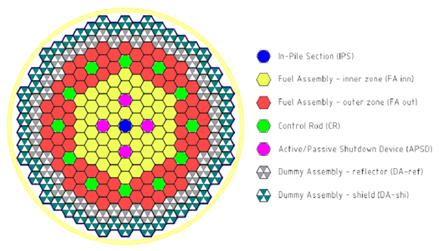
Figure 1. Example of using a single-cell table to construct a figure.

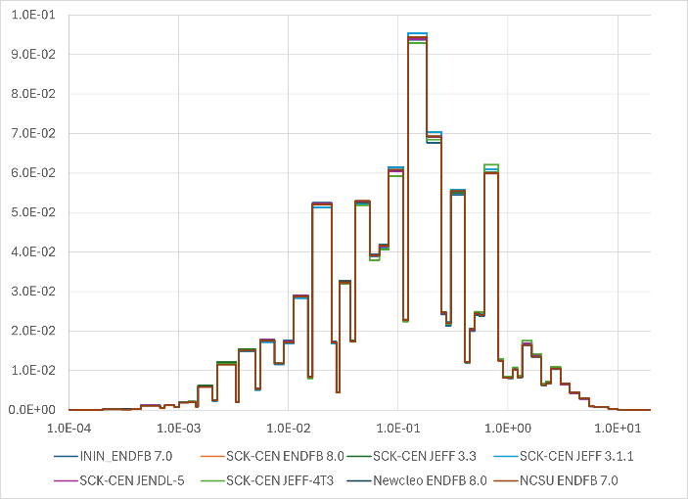 | 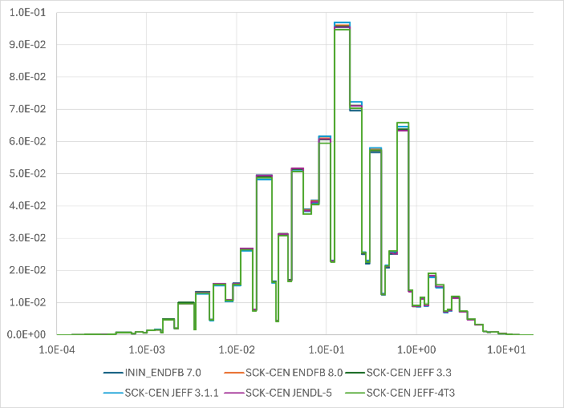
Figure 2. Example of using a table for a figure composed of two graphs.

When converting the document to PDF format, images may lose quality; therefore, it is recommended to use source files with sufficient resolution to ensure that the content remains legible in the final document.

Figure captions should be placed below the figures, using Times New Roman font, size 10, and centered alignment. It is important to ensure that the text within the figures is clearly legible; it is recommended that the font size not be significantly smaller than that used in the figure caption.
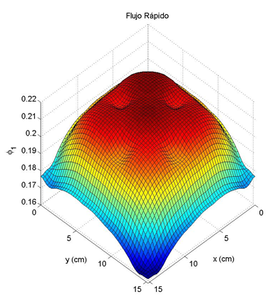
Figure 3. Example of using a table for a figure composed of four graphs.

Tables

Tables should be included within the main text, as close as possible to the paragraph where they are mentioned, using the word “Table” or “Tables” (with the first letter capitalized). However, they should be numbered with Roman numerals.

The use of cell borders and special formatting in the text within tables is at the authors' discretion; however, it is recommended to maintain the simplest and clearest possible format.

Tables I and II show examples of acceptable formats for presenting the same information. Table content should be written in Times New Roman font, size 11.

As with figures, table titles should be written in Times New Roman font, size 10, and centered; however, in this case, the title should be placed above the table.

Table I. Example 1 of a table
Case | Value [b] | Diff
ININ ENDFB 7.0 | 1.8304 | 0.19%
SCK-CEN ENDFB 8.0 | 1.8306 | 0.20%
SCK-CEN JEFF 3.3 | 1.8352 | 0.45%
SCK-CEN JEFF 3.1.1 | 1.8196 | -0.40%
… | … | …
Average | 1.82695 | -

Table I. Example 1 of a table
Case | Value [b] | Diff
ININ ENDFB 7.0 | 1.8304 | 0.19%
SCK-CEN ENDFB 8.0 | 1.8306 | 0.20%
SCK-CEN JEFF 3.3 | 1.8352 | 0.45%
SCK-CEN JEFF 3.1.1 | 1.8196 | -0.40%
… | … | …
Average | 1.82695 | -

Equations

Mathematical formulas must be written clearly to avoid confusion. Equations should be centered and numbered sequentially, with the numbering aligned to the far right. A blank line should be left before and after each equation.

(1)

No indentation should be used when continuing a paragraph after an equation. All paragraphs, as well as headings or titles of sub-subsections, should be separated from the text by a single blank line.

CRITERIOS DE ACEPTACIÓN

Extension and Handing Over Format

Since the paper will be included as a PDF file in the conference proceedings, it is recommended that you convert it directly from Microsoft Word using the "Save as PDF" option. If you use any other tool to convert .docx files to .pdf, you must ensure that the final document retains sufficient quality to be easily readable.

Due to platform limitations, the final PDF file size must not exceed 5 MB.

The document should be between 8 and 14 pages long. If the paper is too long, it is recommended that you divide it into two related papers with different approaches, and submit some pages independently for review.

You must use the International System of Units (SI). All abbreviations must be explained the first time they appear in the text.

Papers that do not meet the stipulated submission requirements will be rejected. Once accepted, the complete papers will appear in the conference proceedings exactly as received, without the possibility of subsequent modifications.

Deadlines

The deadline for receiving complete papers is June 21, 2026, while the deadline for submitting revised papers is August 2, 2026.

Papers received after these deadlines will not be considered for review or acceptance.

Originality

The main criteria considered for accepting submissions are related to the degree of originality, application, quality of presentation, and development of the topic.

Submissions are expected to present a contribution that goes beyond the current state of practice, whether as a result of research, technological innovation, engineering development, or other relevant contribution of interest to the nuclear field.

State-of-the-art studies, literature reviews, or outreach articles may be considered provided they include conclusions, analyses, or contributions of interest to the nuclear community.

Plagiarism and Use of AI

Submitted works must be original and complete contributions that have not been previously presented at similar conferences. In order to preserve the academic quality and scientific integrity of the conference proceedings, manuscripts may be reviewed using text similarity detection tools. If a high level of unjustified similarity is identified, including material previously published by the authors themselves without proper attribution, the work may not be considered for acceptance.

The use of artificial intelligence tools to support writing, translation, editing, or proofreading is permitted, provided that such use is responsible and supervised by the authors. The authors retain full responsibility at all times for the originality, accuracy, and scientific validity of the submitted content.

∗ e-mail od the corresponding author Footer if necessary, in 9-point Times New Roman font.

